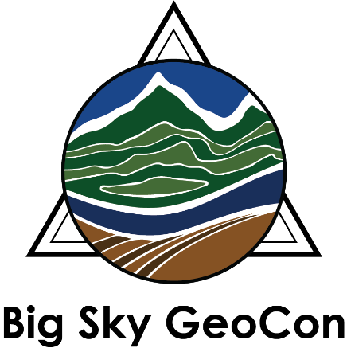

2019 Big Sky GeoCon Student Registrations

The Montana Association of Geographic Information Professionals (MAGIP) is pleased to offer ten (10) student registrations to the Big Sky GeoCon being held in Butte, Montana from April 1-4, 2019. The registrations are awarded in a first-come-first-served manner, and cover the full registration fee for the conference. Please be aware that registrations are only available to students and grad students enrolled in a higher learning institution (state, private, or tribal).

In return for the registrations, students will be expected to assist organizers with conference activities for 8-10 hours during the conference. A coordinator will assist and schedule students. Assistance is needed prior to the start of the conference, during the conference, and during the public night.

All other costs, such as travel, lodging, and workshop fees will remain the responsibility of the scholarship recipient. However, for those students who reside farther than 100 miles from the conference site, travel stipends of $150.00 will be available.

Applications received by 5 p.m. on February 22, 2019 will be reviewed and applicants will be notified of results by February 28, 2019. Preference will be given to those students who are presenting papers, posters, online web maps or mobile applications, with additional consideration given to the responses on the attached application. Registrations will then be awarded based on the order in which the applications are received. Additionally, the review panel will strive for a good geographic distribution of applicants.

To Apply:

To apply for this scholarship, please complete the application form and e-mail it to Jenny Connelley, the student coordinator, at the following address jenny.connelley@gallatin.mt.gov by 5 p.m., February 22, 2019.

Please use the subject line “Big Sky GeoCon Student Registration Application” in your email. You will be notified that the application has been received and is in review.

Big Sky GeoCon Student Registration Application
Application deadline: 5 p.m. on February 22, 2019.
Applicants will be notified of results by February 28, 2019.

Name:

Address: City:

State: Zip Code:

Home Phone: Cell Phone:

Email Address:

Do you wish to be considered for the Travel Stipend? Yes  No 

Name of Institution:

Name of Faculty Advisor:

Email Address of Faculty Advisor:

Please indicate if you are planning to present a paper, poster, on-line web map or mobile application at this year’s conference: Yes  No 

If yes, please provide a title for, and brief description of, your presentation:

Title:

Description:

Please provide one or two brief paragraphs (about 150 words) describing your background and interest in geographical information to be published in the conference program:

